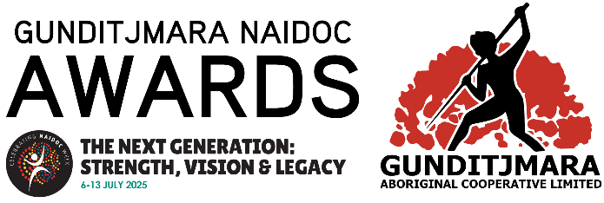

GUNDITJMARA 2025 NAIDOC AWARDS **-** Nomination Form

**Entry guidelines**  
  
**The Gunditjmara Aboriginal Co-operative Ltd NAIDOC Awards celebrate the outstanding contributions and excellence of Aboriginal and Torres Strait Islander peoples within the Gunditjmara Community across three categories – Elder, Community Member and Youth**

**All people nominated for Gunditjmara NAIDOC Awards 2025 must:**

* Be of Aboriginal and/or Torres Strait Islander descent; and
* Identify as an Aboriginal and/or Torres Strait Islander; and
* Be accepted as an Aboriginal and/or Torres Strait Islander by an Aboriginal and/or Torres Strait Islander community
* Must reside in Warrnambool and surrounding districts
* The nominee must make every effort to attend the NAIDOC Week: Opening/Award Ceremony on Monday 7th July 2024
* Shortlisted Nominations will be contacted by 5pm (AEST) COB Wednesday 25th June 2025.

**Nominations must be received by COB 4pm (AEST) on Friday 13th June 2025.**

*All nominations are strictly confidential, and the information provided will be used only to assist in considering the merits of the nomination. All nominations will be viewed by Gunditjmara NAIDOC Steering Committee.*

**Award Category**

**Select from below which award category you are nominating for:**

🞎 Elder of the Year (50+) – Male  
🞎 Elder of the Year (50+) – Female  
🞎 Aboriginal Community Member of the Year (25-49) – Male  
🞎 Aboriginal Community Member of the Year (25-49) – Female  
🞎 Aboriginal Youth of the Year (12-24) – Male  
🞎 Aboriginal Youth of the Year (12-24) – Female

**Details of person lodging this form.**

|  |  |
| --- | --- |
| First Name: |  |
| Last Name: |  |
| Organisation or Community Group (if applicable): |  |
| Street Address: |  |
| City: |  |
| State: |  |
| Post Code: |  |
| Email: |  |
| Phone Number: |  |

🞎 By ticking this box, I declare the above details are correct.

**Details of person being nominated.**

**Nominee Name**

|  |  |  |  |
| --- | --- | --- | --- |
| First Name: |  | | |
| Last Name: |  | | |
| Age: |  | | |
| Heritage (please circle): | Aboriginal | Torres Strait Islander | Aboriginal &Torres Strait Islander |
| Gender (please circle): | Male | Female | Non-binary/other |
| Preferred pronouns: |  | | |
| Street Address: |  | | |
| City: |  | | |
| State: |  | | |
| Post Code: |  | | |
| Contact Phone Number: |  | | |
| Email: |  | | |

**Selection Criteria**

* Demonstrated commitment and contribution to benefit the local Aboriginal community
* Demonstrated excellence in their nominated category
* Demonstrated involvement in the Indigenous community at the local, regional and/or national level
* The individual demonstrates leadership and inspires others
* Goes above and beyond
* Promotes self-determination

**Please support your nomination by writing a short paragraph to each of the selection criteria as listed. Any relevant documentation or evidence supporting your nomination can be attached to this application.**

* How have they demonstrated excellence in their nominated category?
* How is the nominee an inspirational role model for better outcomes for the local Aboriginal Community?
* How has the nominee demonstrated leadership, achievements empowered our community, gone above and beyond?

Disclaimer

*Gunditjmara Aboriginal Co-operative is collecting your personal information and the personal information of the person you have nominated for the purposes of the 2024 NAIDOC Awards selection process. For the same purpose, we may provide this information to our CEO/Board of Directors, Cultural Events Committee and Event Co-ordinators. Gunditjmara Aboriginal Co-operative also intends to produce publications to promote the 2024 NAIDOC Award winners. Providing the requested information is voluntary. If you choose not to provide us with your information we will be unable to assess your application for the award. You must ensure that the person you are nominating has agreed to be nominated for an Award, and agrees to the personal information contained in this nomination form being provided to, and used, by Gunditjmara Aboriginal Co-operative.  Gunditjmara Aboriginal Co-operative will not provide the information collected from you to anyone else outside Gunditjmara Aboriginal Co-operative other than specified above, unless you or the person you have nominated have given consent for us to do this, or we are authorised or required to do so by law. The privacy and security of your personal information is important to us, and is protected by law.*